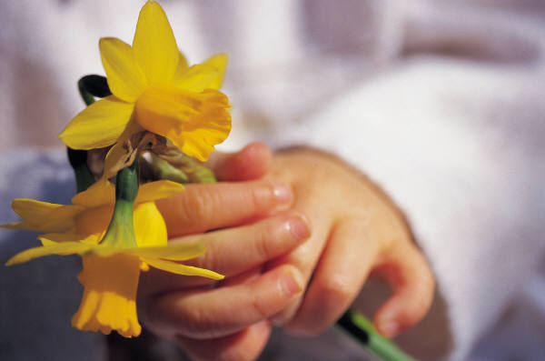
Daily Schedule
6:30-7:00 |  | Breakfast
7:00-8:30 |  | Table Toys/Coloring/Play Dough/Free Play
8:30-9:00 |  | Bathroom/Diapering
9:00-9:30 |  | Snack time
9:30-10:00 |  | Circle Time
10:00-11:00 |  | Outside Play
11:00-11:30 |  | Learning Time (Letters, numbers, shapes)
11:30-12:00 |  | Bathroom/Diapering/Lunch prep
12:00-12:30 |  | Lunch Time
12:30-12:45 |  | Clean Up/Nap Prep
12:45-1:00 |  | Story Time
1:00-3:00 |  | Nap Time or Quiet Time
3:00-3:30 |  | Snack
3:30-4:30 |  | Free Play/Outside Play
4:30-600 |  | Table Toys/Coloring/Play Dough/Free Play

