Meet the problem:
Scenario: Two college co-valedictorians and good friends who lost touch, James and Sarah, reunite ten years after graduation and learn that even though they both graduated summa cum laude with degrees in Business and Communication and have both worked for ten years as senior corporate trainers for two subsidiaries of the same large, national bank, James earns six figures while Sarah does not. James earns significantly more than Sarah.
They Google the wage gap and find the following information:
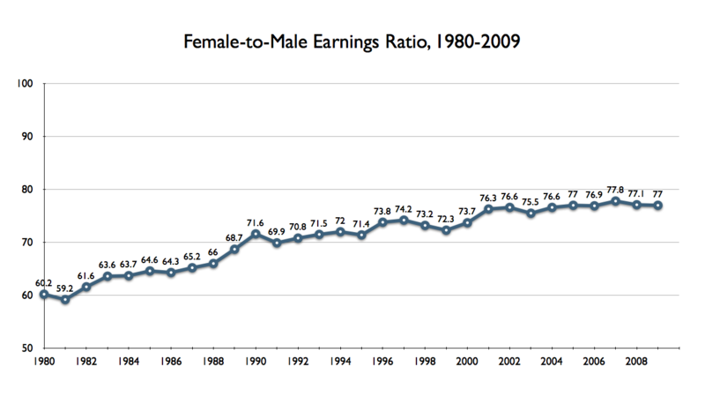
Source:
http://en.wikipedia.org/wiki/Gender_pay_gap

Assignment:
Step 1: (group discussion)
What conclusions can you make by examining this graph?
Make a list of questions you have about this graph.
Step 2:
Watch the “filter bubble” video.
Step 3:
Google “wage gap.”
Step 4: (group discussion)
What is the wage gap?
Compare Google results – to what extent were they filtered by Google algorithms?
How did different website/ sources present the wage gap?
Calculate average salaries by gender based on the wage gap (insert math problems here). If women earn 77 cents for every 100 cents earned by men (when controlling for educational attainment and experience), how much would a woman earn on average when a man in a similar position earns $50,000.
Step 5: (group discussion)
Using your research, formulate a plan or strategy for Sarah to increase her income.
Extra Credit: (community organization and civic involvement)
Volunteer for 10 hours to increase wage equity and write one-page paper about your experience.
Credits:
Phyllis Nissila, Liz Coleman, Sherrill Wight, Megan Perkins, Adrienne Mitchell

