Anne McGrail
Time Management Self-Assessment
For Writing 121 Class. Adaptable to any class.
NOTE: I use this in the “questionnaire” format in Moodle and students can see how they answer once they finish. This can be used with a reflective writing prompt that week in a discussion forum. I have also used it in the Lesson format in Moodle, where I place a value on each of the responses, so at the end of the self-assessment they get a “score” which then can be linked to some feedback that I give them. This could also be an in-class assignment where students could talk in their home groups after they’re done. Follow-up discussions about time management in my own class (with various reading, discussion, drafting and revising/peer review work) are key to making this a valuable activity.
1 . Do you make wise choices with your time, giving the most time to high-priority goals that are linked to your life goals?
Not at all
Rarely
Sometimes
Often
Very Often
2 Do you find yourself completing your homework or studying at the last minute, or asking for extensions for papers and projects?
Not at all
Rarely
Sometimes
Often
Very Often
3 Do you set aside time to plan your week and schedule the different activities that you need to complete in your life roles: (examples: student, friend, partner, employee, parent)?
Not at all
Rarely
Sometimes
Often
Very Often
4 When you look at the number of waking hours in a given week (112 if you sleep 8 hours a night), do you know how you spend each of those hours, including in-class time, homework studying, recreation, food, chores and errands, social and family time?
Not at all
A vague idea
In some areas but not others
Yes, in most of my roles.
Yes, I have an accurate picture of my time use in all my roles.
5 How often do you feel like you are just about to get some serious work done when you are interrupted?
Not at all
Rarely
Sometimes
Often
Very Often
6 Do you use goal setting to decide what tasks and activities you should work on?
Not at all
Rarely
Sometimes
Often
Very Often
7 Do you often find that your schedule is thrown off by "unexpected" things like car break-downs, sick family members or getting called into work?
Not at all
Rarely
Sometimes
Often
Very Often
8 When going about your work, can you say which tasks you are working on are high, medium, or low value?
Not at all
Rarely
Sometimes
Often
Very Often
9 Look at the following picture and circle the sentence that best describes your familiarity with it:
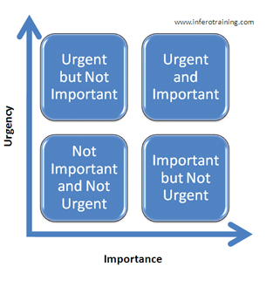
I am not at all familiar with this Time Management Grid or what it means.
I have seen this Time Management Grid but I have never used it.
I have seen this Time Management Grid and know what it means.
I have used this Time Management Grid a few times.
I always use some kind of Time Management Grid to organize my time.
10 Are you stressed about deadlines and commitments?
Not at all.
Rarely.
Sometimes.
Often.
Very Often.
11 Do distractions often keep you from working on critical tasks?
Never.
Rarely.
Sometimes.
Often.
Very Often.
12 Before you commit to doing something, do you check to see whether it fits within your time constraints and goals?
Never.
Rarely.
Sometimes.
Often.
Very Often.

