Problem Based Learning Exercise

Team: Susan Evans, Jen Klaudinyi, Damian McDonald, Dan Welton

Overall Task: Bring Students awareness to the “Filter Bubble” and how it influences the visual & technical information they encounter on the web.

Factors to Consider: Narrow focus, limited choices

Computer location, computer type, mobile devices, and account logins all effects search results

Focus of the assignment is to empower the students to make effective use of the resources they use for researching online video tutorials to obtain a broader range of outcomes with less filtering.

Format of delivery could be the entire class.

Show “Filter Bubble” video. Then examples will be show of the same experiment done by instructors previously. See examples below:

Jen’s PC top @ home Fire Fox and
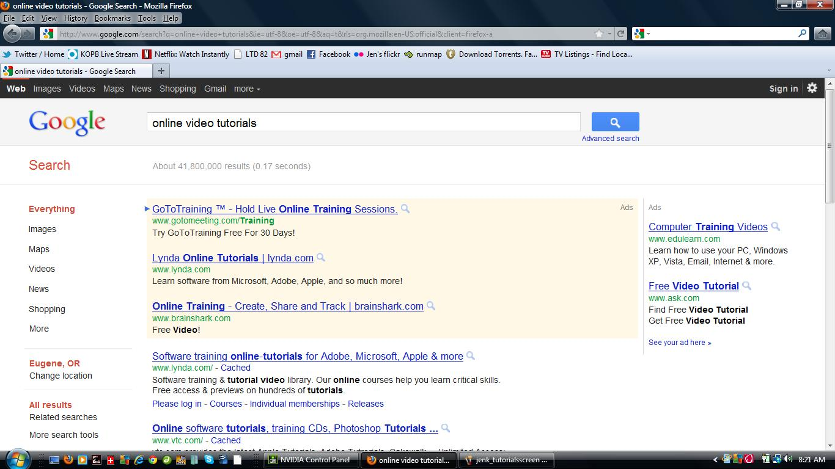

Damian’s Mac @ home – Firefox browser

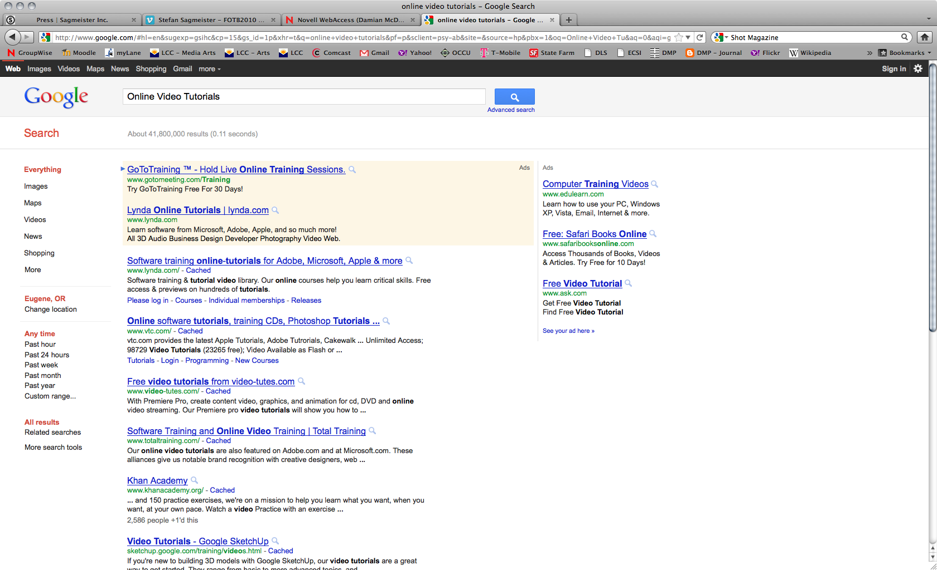

Susan’s PC – Fire Fox
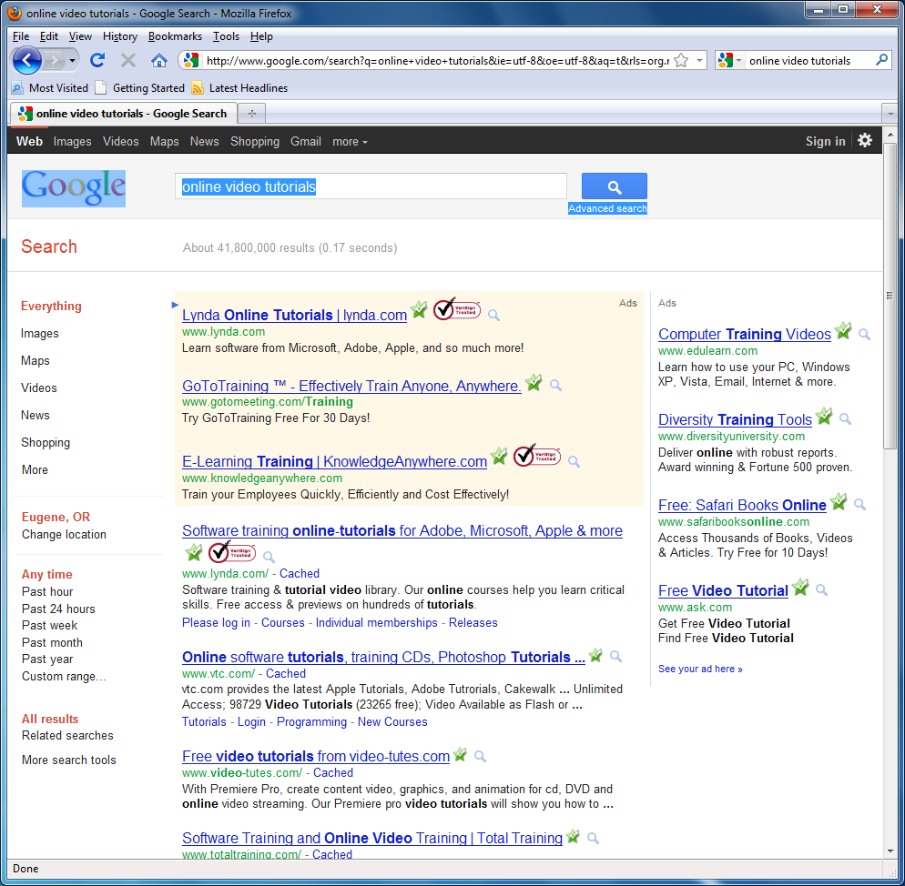

Groups will be chosen to search the term “Online Video Tutorials”. One group will be a “Mac” group using Macs to search the term, a “PC” group, Different browser group, and iPhone group. They will be asked to take a screen shot of the first page of the Google search and upload that to a Forum on Moodle and compare the outcomes.

Then after a discussion on the differences and similarities the student will be asked to discuss possible ways of broadening search capabilities that allow for a larger pool of information. For example, changing browser preferences, Google Chrome, clearing browser cache, etc.

Resources needed would be computer access in library labs, Media Arts labs, and CIT labs. Some home computer access and Moodle.

