***Title III Evaluation Report on   
Learning Communities and Faculty Development 2011-2012***Submitted by Anne B. McGrail, Ph.D,   
Activity Director for Faculty Development Title III, Lane Learning Communities Coordinator & English Faculty

**Report Summary**:

1. **First Year Experience Learning Communities—Enrollments and participation**
2. **Curricular Infusions: Personal Responsibility and Interdependence**
3. **Tea and Topics: Talk About Teaching**
4. **Development and Support for Online Student Information sessions in Moodle**
5. **Reading Together Books for all FYE Students**
6. **CD Support for FYE Faculty to Create Curriculum for Reading Together Project**
7. **Institutionalizing FYE Learning Communities Processes and Policies**
8. **A Handbook for First Year Experience Faculty**
9. **Spreading the Language of Title III *Engaging Students Program***
10. **Ice Cream Social—Connecting Learning Communities faculty past, present and future**
11. **Appendices**

**First Year Experience Learning Communities:**

* 25 sections offered this year (see Appendix: “Learning Communities Offerings 2011-12) taught by 43 Lane faculty (See Appendix C)
* Two sections of “Power Write”—a new Learning Community for business majors—offered Winter and Spring terms
* New Accelerated Learning Community developed linking Writing 121 with Effective Learning 115 for 2012-13 offering.

**Curricular Infusions: Personal Responsibility and Interdependence**

Twenty-one faculty developed curricular infusions for their courses across seven disciplines (see Appendix C)

**Tea and Topics: Talk About Teaching**

The *Engaging Students Program*’s signature faculty development activity, “Tea and Topics: Talk About Your Teaching,” won a Schafer Innovation Award of $500.00 for excelling in five selection criteria: effectiveness, efficiency, affordability, replicability and creativity. The award will support 2012-13 sessions.

Seventy-nine faculty attended seven “Tea and Topics” events in 2011-12 (see topics below and Appendix C).

* October: Merrill Watrous talks about using Doug Lemov's book, *Teach Like a Champion* in her college classes
* November: "Teaching Core Learning Outcomes and Student Success" with Assessment Team members Barbara Breaden and J.S. Bird
* January: "Interdependence and Personal Responsibility: INfusing the 2011-12 Student Success/On Course Principles Across the Curriculum"
* Feburary: "Innovations in Developmental Education" Join ALS faculty Adrienne Mitchell, Steve McQuiddy and others as they discuss what the Academic Learning Skills faculty are doing to increase pre-college students' success.
* March: "Student Writing Across the Curriculum" with Writing faculty Siskannah Naynaha and Kate Sullivan
* April: "DIY Infusions: Checking in on Integrative Assignments and College Success Infusions": faculty share their infusions, integrative assignments, etc. and plan for summer work.
* May: "Copyright and Fair Use in the Digital Age: Evolving Understanding and Responses."

**Development and Support for Online Student Information sessions in Moodle**

Title III supported three faculty in their development of a Moodle online advising module. Since their initial development, most majors now have a module for students to visit for advising information through videos, documents, weblinks and messaging to Lane advisors directly.

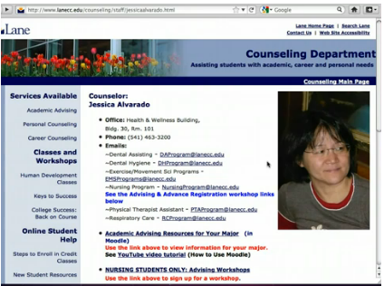 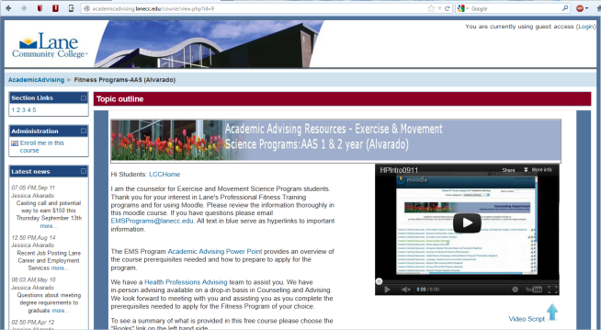

**Reading Together books for all FYE students**

Common Intellectual Experiences are a “High Impact Practice” for student success, and Lane’s Reading Together has become a signature common learning event. Each year, the college chooses a book for faculty, staff and students to read, with the author of the book coming to a community and special student event in Spring. This year’s book, *You are Not a Gadget* by Jaron Lanier, was chosen and been well received by faculty and staff. In June 2012, Lane purchased 413 copies of the book to distribute to First Year Experience learning communities students and faculty free of charge to encourage curricular integration of the book.

**CD support for FYE faculty to create curriculum for Reading Together Project**

Eighteen faculty were granted curriculum development support to directly integrate Reading Together assignments into their courses.

**Institutionalizing FYE Learning Communities Processes and Policies:**Annual Planning Meeting with Administrative Coordinators and Clear Add/Drop Policy for Linked Courses

Anne McGrail met with all Administrative Coordinators involved in Learning Communities planning and course building. She developed and shared an annual task calendar for all staff involved in building learning communities. (See sample screen capture below). Administrative coordinators shared their concerns about difficulties with learning communities, including creating a calendar with a master list of planned LCs (which appears below in Appendix B); spreading the learning communities throughout the day and week to avoid “clumping” of learning communities and consequent enrollment and room-scheduling difficulties; mixed vs. pure cohorts and the effects of graduated registration on enrollment.

The group found the meeting very helpful and it was agreed that an annual January meeting to address concerns as they arise should be scheduled.

A clear administrative policy was articulated in 2011-12 as well: post-it notes on the advertised learning communites schedule would now make it clear that students cannot register for learning communities and then drop one of the classes without dropping both classes (see screen capture below). This was to avoid the problem of students looking for stand-alone writing courses that fit their schedules and then dropping the College Success class; such a practice takes valuable learning communities seats away from first-year students. Notes for this meeting are in Appendix C.

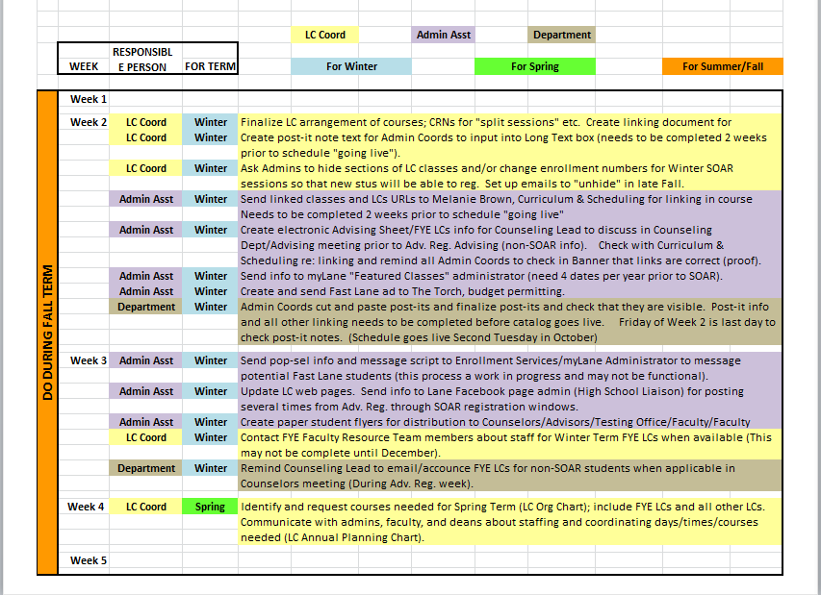

***Above***: Sample page from Administrative Task Calendar by term and responsible party.

***Below***: Screen capture of drop policy for learning communities classes in yellow.

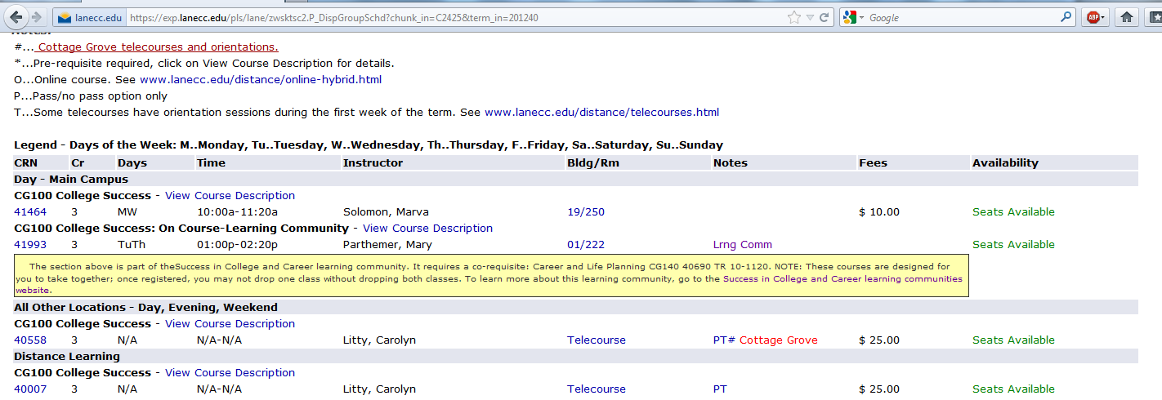

**A Handbook for First Year Experience Faculty**

In Summer 2012, Anne McGrail created a Faculty Handbook for Learning Communities faculty. It’s located here: <http://www2.lanecc.edu/lc/fresources/faculty-handbook> This handbook helps with institutionalizing learning communities and first year experience at Lane, putting a wealth of information at everyone’s fingertips.

**Spreading the Language of Title III *Engaging Students Program***The language of learning communities and integrative learning has spread throughout the culture of the college. One way that we have disseminated information about the program and its goals and accomplishments has been through Spring Conference (inservice). Anne McGrail created a four-minute video entitled “[Helping Students Become Master Learners](http://www.youtube.com/watch?feature=player_embedded&v=B3Ap-SSD9SA) “ which was filmed by Lane and presented at Spring Conference. The goals of the “TED Talk”-like presentation was to reinforce the importance of integrative learning—a key High Impact Practice that Title III and Roadmaps projects are focusing on this year.



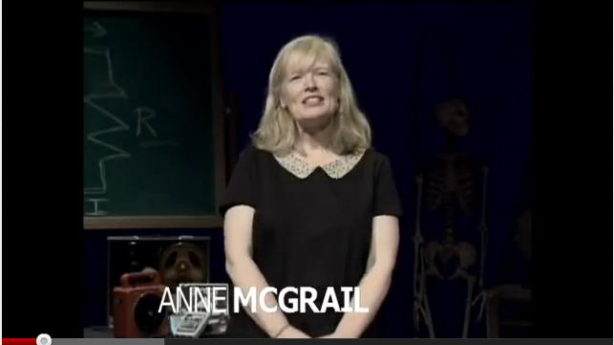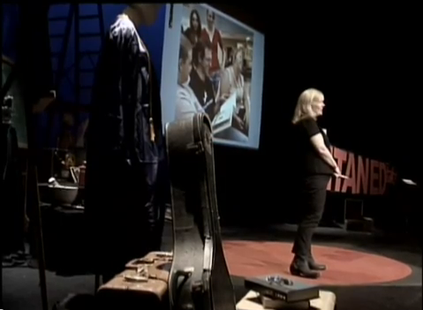

**Ice Cream Social—Connecting Learning Communities faculty past, present and future**

Just as academic and social integration are key for students, so are they key for faculty and staff devoted to improving student success. More than twenty faculty and staff, including executive deans and the vice president for academic and student affairs, attended the end-of-year ice cream social to reconnect across disciplines and make plans for 2012-13.

**Appendix A:  
Master Participation List in *Engaging Students*  Program Faculty Development Activities**

**Summary:**

* First Year Experience Learning Communities Faculty 2011-12 =**43**
* Tea and Topics Attendance 2011-12=**79**
* Curricular Infusion “Personal Responsibility and Interdependence” Grant Recipients=**21**
* Reading Together Mini-Grant Recipients=**18**
* Learning Communities Ice Cream Social Attendees=**21**+
* Faculty Mentors for FYE Learning Communities =**4**
* Student Peer Mentors for FYE Learning Communities =**2**

**FIRST YEAR EXPERIENCE LEARNING COMMUNITIES FACULTY 2011-12**

1. Beth Landy
2. Marva Solomon
3. Jessica Alvarado
4. J.S. BIRD
5. David Bochoven
6. Mortenson Camilla
7. Nate Capehart,
8. Christina Salter
9. Christine Ngo
10. Daphne Gabrieli
11. Debby Ganser
12. Eliot Treichel
13. Gail Stevenson
14. Sandy Jensen,
15. Kathleen Shull
16. Kim Morton
17. Lynn Untz
18. Margaret Wofford
19. Mary Parthemer
20. Siskanna Naynaha,
21. Phyllis Nissilla
22. Richard Murrell
23. Rosanna Walker
24. Steve Selph
25. Art Peck
26. Siskanna Naynaha
27. Kate Sullivan,
28. Tim Shaner
29. Tulsi Wallace (Power Write)
30. Drew Viles,
31. Sherril Wight
32. Jill Siegfried
33. Jessica Alvarado
34. Anthony Hampton
35. Liz Coleman
36. Dave Oatman
37. Carol Watt
38. Jered Westover
39. Steve McQuiddy
40. Heather Ryan
41. Bobbi McLean
42. Josh Daniel

**TEA & TOPICS ATTENDANCE 2011-12**

1. Alvarado Jessica
2. Bird JS
3. Bradley Jill
4. Brau Mary
5. Breaden Barbara
6. Bronsema Max
7. Brown Jensen Sandy
8. Burley Hali
9. Carkin Susan
10. Christian Sonya
11. Clandos Rosemary
12. Clemons Marv
13. Coleman Liz
14. Coronado Ian
15. Couch Denise
16. Coulthard Debby
17. DeWolf Dawn
18. Doctor David
19. Foust Mary
20. Ganser Debby
21. Hampton Anthony
22. Harvey Ronald
23. Haynes Pamela
24. Higgins Cybele
25. Hill Richard
26. Hogle Eric
27. Howard Christina
28. Johnsen Norm
29. Keene-Wilson Meredith
30. Kepka Jenn
31. Kuhar Mary Jeanne
32. Lamoreaux Alise
33. Levine Keren
34. Lodge Lynn
35. Lopez Rosa
36. Ma Perry
37. McDonald Michael
38. McGrail Anne
39. McNair Don
40. McNaughton Don
41. McQuiddy Steve
42. Mitchell Adrienne
43. Morrison-Graham Katie
44. Mort Gary
45. Morton Kim
46. Motouji Satoko
47. Murdoff Ken
48. Naynaha Siskanna
49. Oatman David
50. Owen Claudia
51. Parthemer Mary
52. Pepe Vanessa
53. Phillips Bobbi K
54. Pineda Marika
55. Pinkas Tamara
56. Powell Tamberly
57. Pray Elaine
58. Richards Andrew
59. Ripley Doug W
60. Roethle Chris
61. Rosenow Ce
62. Salter Christina
63. Schaefer Karen
64. Shields Colleen
65. Smyth Douglas
66. Solomon Marva
67. Soriano-Cervantes Leslie
68. Spicer Arwen
69. Stevenson Gail
70. Sullivan Kate
71. Tullis Lynn
72. Uhlig Elizabeth
73. Wallace Tulsi
74. Wanstall Clive
75. Warner Alice
76. Watrous Merrill
77. Watt Carol
78. Wight Sherrill
79. Wilson Molloy

**CURRICULUM DEVELOPMENT MINI-GRANT RECIPIENTS**

**“Infusing Personal Responsibility and Interdpedence” into Curriculum**

1. Beasley, Amy
2. Bosworth, Shelly
3. Bronsema, Max
4. Clandos, Rosemary
5. Crosthwaite, Cris
6. Duyck, Marc
7. Higgins, Cybele
8. Hovekamp, Tina
9. Levin, Mara
10. Levine, Keren
11. Lushia, Sarah
12. Pepe, Vanessa
13. Shull, Kathleen
14. Soraci, Gabriella
15. Spicer, Arwen
16. Steinber, Shalimar
17. Sullivan, Barbara
18. Thompson, Eileen
19. Watt, Carol
20. Webb, Victoria
21. Yui, Amber

**READING TOGETHER CURRICULUM DEVELOPMENT GRANTS**

1. BAYLESS, MARGARET
2. BEASLEY, AMY
3. CLANDOS, ROSIE
4. GARRY OLDHAM
5. KROIK, POLINA
6. LUSHIA, SARA
7. MCGRAIL, ANNE
8. MCQUIDDY, STEVE
9. NAYNAHA, SISKANNA
10. OATMAN, DAVE
11. SHITABATA, RUSSELL
12. SORACI, GABRIELA
13. STEVENSON, GAIL
14. THOMPSON, EILEEN
15. WALKER, ROSANNA
16. WATROUS, MERRILL
17. WIGHT, SHERRILL
18. ZIMMERMAN, KEN

**ATTENDEES JUNE ICE CREAM SOCIAL**

1. Sonya Christian
2. Don McNair
3. Andrea Newton
4. Stan Taylor
5. Dennis Gilbert
6. Mary Parthemer
7. Katie Morrison Graham
8. Russell Shitabata
9. Jennifer Von Ammon
10. Liz Coleman
11. Lida Herburger
12. Steve Selph
13. Deanna Murphy
14. Gail Baker
15. Margaret Bayless
16. Jill Bradley
17. Ellen Cantor
18. James Florendo
19. Anne McGrail
20. Gerry Meenaghan
21. Susan Carkin

**FACULTY MENTORS FOR COLLEGE SUCCESS, MATH, WRITING, ACADEMIC LEARNING SKILLS**

Sandy Jensen (Writing), Steve Selph (Math), Kim Morton (College Success), Liz Coleman (Academic Learning Skills)

**FYE LIBRARY RESOURCES PAGE** This page is being designed by Lane librarian Jen Klaudinyi. This past year she has spent a lot of time working on e-portfolios and Open Educational Resources, and so the project is ongoing and under construction.

**Appendix B:  
FYE Learning Communities Offerings Fall 2011-Fall 2012**

**Note for First Year Learning Communities: enrollment numbers for mixed/split cohorts accompany classes with split enrollments. Paired sections are single-spaced.**

Classes in **purple**: Counseling   
Classes in **brick underline**: ALS   
Classes in **green**: LLC   
Classes in **teal underline:** Math

**Fall Term 2011**

**Fast Lanes to Success**

**CG100** TR 1-220 17 with **WR95**TR 1000-1150  **G100** TR 1-220 17 with  **WR115** TR 2:30 – 4:20

**CG100** MW 830-950 17 with **WR115**  MWF 10:00 – 11:20 (10:50)  
**CG100** MW 830-950 17 with **WR115**  MWF 10:00 – 11:20 (10:50)

**CG100** MW 1-220 17 with  **WR115** MW 10:00 – 11:20 F10:00-10:50  
**CG100** MW 1-220 17 **WR115** MW 10:00 – 11:20 F 10-10:5010:50

**CG100** MW 10-1120 (24) with  **WR121** MWF 12:00 – 1:20 (12:50)  
 **CG100**MW 10-1120 with  **(10) WR121** MWF 12:00 – 1:20 (12:50) (10)

**CG100** TR 830-950 (24) with  **WR121** T/R 10:00 – 11:50  
**CG100** TR 830-950 (10) with  **WR121** T/R 10:00 – 11:50 (10)

**Power Write**

**BA101** TR 10:00-11:50 a.m with  **WR121** TR 12-1:50

**Write Way to Learn**

**EL115** TR  1200-1320 with **WR115** T/R 10:00 – 11:50 (18)  
**EL115** TR  1200-1320 with **WR115**  T/R 10:00 – 11:50 (14+4)

**EL115W** 12:30 - 1:50 with  **WR121** TR 10:00 - 11:50 (24)

**Success in College and Career**

TR 1-220 **CG100** with  **CG140** TR 10-1120

**Math Success**

**CG100** TR 10-1120 with  **MTH020**  MWF 10-10:50  
**EL115**  TR 1200-1320 with **MTH 060** TR 8:30-9:50 & F 9-9:50

**Beyond the Field**

**CG100** TR 10:00-11:20

**WR 121** - T/R, 12:00 - 1:50 8 spots  
WR 115 - T/R, 12:00 - 1:50 8 spots

**RD 80, WR90, WR95**—TBA 3 spots

**Women in Transition**

CG 220 - M 10 am - 1:50 pm with CG 140 T W 10 am - 12:50 pm CG 220   
CG 220 T 1:00 – 4:50 pm with CG 140 T R 1:00– 3:50 pm  
CG 220 T 5:30 – 9:20 pm with CG 140 T R 5:30 – 8:20 pm  
CG 220 M 2:00 - 5:50 pm with: CG 140 T W 2:00 - 4:50 pm

**Winter 2012**

**Power Write**

**Bus101**TuTh 12:00p-01:50p with **WR121** 3152 TuTh 2:00 - 3:50

**Fast Lanes to Success**

**WR115** T/R 2:30 - 4:20 with **CG100** TR 1:00 - 2:20 (17)  
**WR115** T/R 2:30 - 4:20 with **CG100** TR 1:00 - 2:20 (17)

**WR115** MWF 2:30 - 4:20 (3:30) with **CG100** MW 1:00 - 2:20 (17)  
**WR115** MWF 2:30 - 4:20 (3:30) with **CG100** MW 1:00 - 2:20 (17)  
 **WR121** MWF 10:00 - 11:20 (10:50) with **CG100** MW 8:30 - 9:50 (24)  
**WR121** MWF 10:00 - 11:20 (10:50) with **CG100** MW 8:30 - 9:50 (10)

**WR121** MW 2:00 - 1:50 with **CG100** MW 10:00 - 11:20 (24)  
**WR121** MW 2:00 - 1:50 with **CG100** MW 10:00 - 11:20 (10)

**Write Way to Learn**

**EL115** TR 1200-1320 (18) with **WR115**  T/R 10:00 – 11:50 (18)  
**EL115** TR 1200-1320 (14) with **WR115** T/R 10:00 – 11:50 (14+4)

**EL115**W 12:30 - 1:50 with **WR121** TR 10:00 - 11:50 (24)

**Success in College and Career   
CG100** TR 1-2:20 with **CG140** TR 10-1120

**Math Success**

**MTH20** MWF 10-10:50 with **CG100** MW 11:30 - 12:50 (31)  
 **MTH 060** TR 10:30-11:50 & F 11-11:50with **EL115** TR 9:00-10:20 (31)

**Show Me the Money**

**WR105** MF 12:00 - 12:50 with **CG105** W 12-1:50   
**WR105** MF 1:00 - 1:50 with **CG105** W 12-1:50

**Women in Transition**

CG 220 - M 10 am - 150 pm With CG 140 T W 10 am - 1250 pm  
 CG 220 T 1 pm - 450 pm With CG 140 T R 100 – 350 pm  
 CG220 T 530 – 920 pm with CG 140 T R 530 – 820 pm

**Spring 2012**

**Writing Fast Lanes**

**WR121** MWF 10:00 - 11:20 (10:50) with **CG100** MW 1:00 - 2:20 (24)  
**WR121** MWF 10:00 - 11:20 (10:50) with **CG100**MW 1:00 - 2:20 (10)

**WR115** T/R 8:00 - 9:50 with **CG100** T/R 10:00 - 11:20 (17)  
**WR115** T/R 8:00 - 9:50 with **CG100** T/R 10:00 - 11:20 (17)

**WR115** T/R 10:00 - 11:50 with **CG100** T/R 8:30 - 9:50 (17)  
**WR115** T/R 10:00 - 11:50 with **CG100** T/R 8:30 - 9:50 (17)

**Math Success**

**MTH20**MWF 10-10:50 with **CG100** MW 11:30-12:50  
**MTH 060** TR 10:30-11:50 & F 11:00-11:50 with **EL115** TR 8:30-9:50

**Success in College and Career**

**CG100** TR 1-2:20 with **CG140** TR 10-1120

**Women in Transition**

CG220 M10:00 -1:50 with **CG140**T W 10 - 12:50  
CG 220 Tues 1 - 4:50 with: **CG140**T with Thurs 1:00 - 3:50  
CG 220 M 2:00- 5:50 with **CG140**T W 2:00 – 4:50   
CG 220 Tues 5:30 – 9:20 with: **CG140** Thurs 5:30 – 8:20

**Summer 2012**

**Women in Transition**

CG 220 M 10 am - 1:50 pm Link CG 140 T W 10 a - 12:50 p

**Fall 2012**

**Fast Lanes to Success  
CG100** TR 1-220 17 with WR 95 TR 1000-1150 |  
**CG100** TR 1-220 17 with  **WR115** TR 2:30 – 4:20

**CG100** MW 830-950 17 with **WR115**  MWF 10:00 – 11:20 (10:50)  
**CG100** MW 830-950 17 with **WR115**  MWF 10:00 – 11:20 (10:50)

**CG100** MW 1-220 17 with  **WR115** MW 10:00 – 11:20 F10:00-10:50  
**CG100** MW 1-220 17 +  **WR115** MW 10:00 – 11:20 F 10-10:5010:50

**CG100** MW 10-1120 with  **WR121** MWF 12:00 – 1:20 (12:50)  
**CG100**MW 10-1120 with  **WR121** MWF 12:00 – 1:20 (12:50) (10)

**CG100** TR 830-950 with  **WR121** T/R 10:00 – 11:50  
**CG100** TR 830-950 with  **WR121** T/R 10:00 – 11:50 (10)

**Power Write**

**BA101** TR 10:00-11:50 a.m with  **WR121** TR 12-1:50

**Write Way to Learn**

**EL115** TR  1200-1320 with **WR115** T/R 10:00 – 11:50  
**EL115** TR  1200-1320 with **WR115**  T/R 10:00 – 11:50  
**EL115**W 12:30 - 1:50 with  **WR121** TR 10:00 - 11:50

**Beyond the Field**

**CG100** TR 10:00-11:20

**WR 121** - T/R, 12:00 - 1:50 8 spots  
WR 115 - T/R, 12:00 - 1:50 8 spots

**RD 80, WR90, WR95**—TBA 3 spots

**Success in College and Career**

TR 1-220 **CG100** with  **CG140** TR 10-1120

**CG100**

**Math Success**

**CG100** TR 10-1120 with  **MTH20** MWF 10-10:50  
**EL115**  TR 1200-1320 with MTH 060 TR 8:30-9:50 & F 9-9:50

**Women in Transition**

CG 220 - M 10 am - 1:50 pm with CG 140 T W 10 am - 12:50 pm CG 220   
CG 220 T 1:00 – 4:50 pm with CG 140 T R 1:00– 3:50 pm  
CG 220 T 5:30 – 9:20 pm with CG 140 T R 5:30 – 8:20 pm   
CG 220 M 2:00 - 5:50 pm with: CG 140 T W 2:00 - 4:50 pm

**Appendix C  
Notes from Learning Communities Administrative Coordinators Meeting 5.24.11**

**Update on “rolling” in June for winter and spring of the next year: I have sent an email to Darlene and have heard back from Angela Miller that this shouldn’t be a problem. Still waiting to hear about any kinks or unintended consequences.**

**Calendar of Planning**

Anne passed out her work flow document “From Course Identification/Staffing to Registration and Publicity” and pointed out that as the college works to streamline LC work, the faculty LC coordinator is moving some of the tasks associated with course building/LC production to the administrative coordinator associated with learning communities (currently Lida Herburger, who delegates some of the work to Liz Pratt at this point.) The tasks that read “Department” on the spreadsheet are those that admin coords building LC sections can follow.

I am sending an electronic copy of the work flow spreadsheet so that you can have it in color.

**Master List of Planned Learning Communities for Fall 2012-Spring 2013 and beyond**

I will send out the updated version of this as soon as it’s complete. We’ll want to look at it and make some changes if necessary. I’m attaching a draft and asking that Lida create a spreadsheet that might be more helpful in the long run.

**Hiding/unhiding courses**

This is a laborious process, but unavoidable. We decided that the LC Coord would set up email reminders to make sure that the admin coords remembered to hide/unhide in a timely manner. This is already in the work flow chart but perhaps could be sent a little earlier.

**Staffing issues and Addressing different departmental cultures around faculty course assignment and days/times taught.**

We discussed how different divisions under different deans staff sections and do planning differently. With learning communities taking extra planning and curriculum development, they are sometimes difficult to staff, and contracted faculty don’t always want to teach them. We had some agreement that we could “sweeten the pot” a little by offering some stability to PT faculty who plan to teach in the learning community, by offering days/times that are most desirable, and by making it very clear that there is CD support for new faculty teaching in LCs. The LC Coord will make up an easy flyer for admins to use to “market” LCs to new faculty. Links and support are already available here: <http://www.lanecc.edu/lc/fresources/FacultyCDSupportLCs.htm>

Some departments build the schedule that is best for students and then faculty select from what’s available. Other departments have faculty decide what and when they want to teach. This is out of the hands of admin coords but there might be some changes if we can get an annual planning schedule.

**Spreading the days/times schedule**

We discussed the difficulties surrounding finding rooms for LCs, and the complexities of dealing with faculty demands for particular rooms etc. Rooms are assigned so late in the game that it makes course building difficult.

**Beyond the Field: Issues with mixed cohorts**

Karen Waddington is the advisor for athletes and she is going to work to plan student athletes’ schedules so that they have 15 credits and so that they are moving toward their degree completion ASAP. We discussed that the best way to do this was to offer the Beyond the Field, which counts as an elective plus a writing course; if students are not placed into college-level writing, then we have 3 slots each in RD80, WR90, WR95 for them to take. Karen will let Lynn and Linda know which CRNs students are signing up for so that we don’t have the slots hidden after they’ve registered by themselves. We all agreed that this cohort would be a great one to intentionally advise into their Math class at the same time, making sure that they get at least 12 credits including their Beyond the Field plus their athletics 2 credits. They could conceivably take one more 3-credit class depending on their math placement.

**Effects of Graduated Registration Process**

It was agreed that some of the scheduling difficulties are eased with the new registration process. Rodney asked that we have some flexibility to cancel at the last minute when staffing or enrollments don’t work.