Welcome!  Your CallXpress® system provides access to voice messages.  Before You Start  Gaining Access to Your Mailbox  1. Call the internal or external number.  2. If you are off campus, press # to be prompted for your mailbox number.  3. Enter your subscriber mailbox number.  4. Enter a security code (if provided by admin.) | Getting Started  After Recording a Message | While Listening to a Message  www.avst.com  CallXpress and AVST are registered trademarks of Applied Voice & Speech Technologies, Inc.  © 2009 Applied Voice & Speech Technologies, Inc. All rights reserved. | Setting Up Your Mailbox  
  CallXpress internal number | 3535
  CallXpress external number | 463-3535
  Subscriber mailbox number
  If you want to … | Enter
  Listen to new messages | 1
  Record message for another subscriber | 2
  To delete a message | 4
  To save a message or listen to saved messages | 5
  Review, forward, delete, save messages | 6
  Listen to and recover messages marked for deletion (in this session only) | 7
  To exit the system | * * * *
  Mark the message urgent | 0 2
  Request a return receipt | 0 5
  Request future delivery | 0 1
  Restrict forwarding of the message | 0 3
  If you want to … | Enter
  Increase playback speed | 1 4
  Decrease playback speed | 1 7
  Increase playback volume | 1 6
  Decrease playback volume | 1 9
  Skip ahead five seconds | 9
  Skip back five seconds | 3
  Skip to the next message | 7
  If you want to … | Enter
  Change your busy greeting | 3 1 3 1
  Change your name recording | 3 1 5
  Change your out-of-office greeting | 3 1 3 3
  Change your password | 3 1 4
  Change your standard greeting | 3 1 3 2
  Set automatic message forwarding† | 3 2 4
  Set Immediate Message Notification† | 3 1 1
  Set message presentation ordering | 3 2 5

How to Print the CallXpress Pocket Guide
This Call Xpress Pocket Guide has been produced as a completely editable Microsoft Word document. To produce it, do the following:
- Print the document double-sided.
  - The margins of this document are set at .5”. If Microsoft Word produces a dialog box reading “The margins of this Document are set outside of the printable area,” select Yes and continue to print.
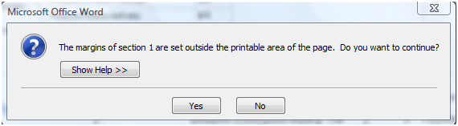

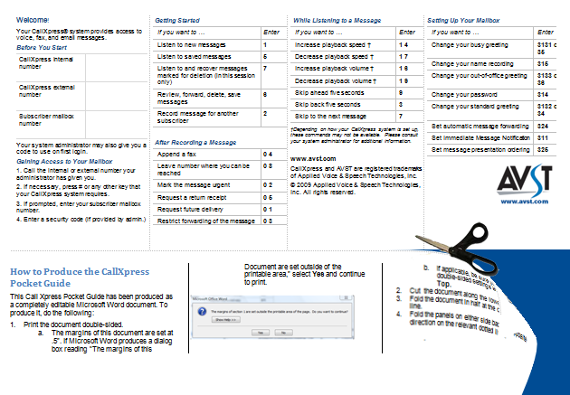
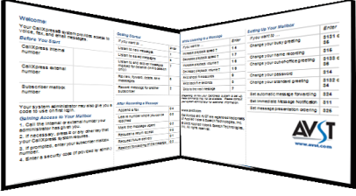
- Cut the document along the lower dotted line.
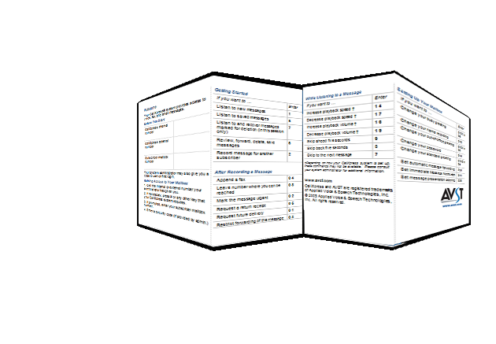
- Fold the document in half at the center dotted line.
- Fold the panels on either side back the opposite direction on the relevant dotted lines.

.

Listening - Main Menu |  |  |   pocket guide  P/N 1081-50119-00 Rev01 (7.80)
  New messages 1 | Saved 5 | Deleted 7
  Selected messages
  6, then 1 to listen | 2 to forward | 4 to delete | 5 to saveMessage Ordering: 1. Voice, 4 Outside callers, 5 Specific sender, 9 All
  Listening Options
  Pause
  1, then 1 to resume | 3 to change language† | 4 or 7 to + or – speed † | 6 or 9 to + or – volume †| 5 to bookmark | 7 to resume from bookmark Forward | 2
  Delete+ or – 5 sec.3 or 9 | 4 |  | Save | 5
  Review | 6 |  | Skip to Next | 7
  Reply | 8, then 1 to select mailbox | 2 to record | 3 to transfer to an extension | 4 to transfer to number
  Info | 0, then 0 for message info | 1 to select message | 2 to cancel | 7 to select all | 8 to cancel all
  Recording – Main Menu
  Record and Send | 2
  Stop Recording | 2
  Recording Options
  Approve to Send | #, then Mailbox number, then # to send
  Pause or Continue | 2
  + or – 5 seconds | 3 or 9
  Start over | 4
  Review | 6
  Set Routing Options | 0, then 1 for future delivery | 2 to set URGENT status | 3 to restrict forwarding | 4 to append a fax | 5 to request a receipt | 8 to leave callback number
  Use * to remove last number entered or return to previous menu, ** to cancel message
  † These commands may not be available.
  Please consult your system administrator.
  User Options – Main Menu
  Personal Options | 1, then 1 to change message| 2 to change daily reminder | 3 to record greeting (then 1, 2 or 3 for busy, standard or out-of-office) | 4 to change security code | 5 to record name | 6 to record message for mailbox sponsor | 7 to change language | 8 to change sms notification
  Messaging Options | 2, then 2 to record name | 3 to change distribution list | 4 to change message forwarding | 5 to change presentation order | 6 to change envelope settings
  Automated Attendant | 3, then 1 to change call screening | 2 to change call blocking | 3 to change extension-specific processing | 4 to change diverted call processing
  Record Greeting | 4 for standard greeting | 5 for busy greeting | 6 for out-of-office greeting

