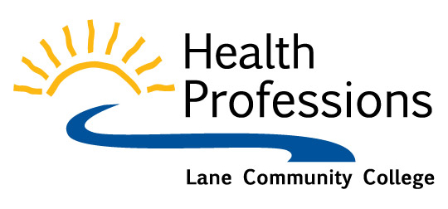
Dear Curriculum Committee:

Subject: Fire Science Dual Program with Paramedic and Chemeketa Community College

We have proposed entering into a collaborative relationship with Chemeketa Community College to offer a Fire Science Program to LCC students without the cost of start-up or offering new courses. It is proposed that all Paramedic and pre-requisite courses belong to LCC,.and all of these courses will be taken at LCC. All Fire Science courses will be taken through Chemeketa CC. These additional classes will be taken either online, at LCC (with CCC instructors), at on-site labs (in Lane county) and, in rare instances, taken in Marion county.

The majority of EMS agencies in Oregon, and across the country, are joint Fire/EMS systems. These agencies often look for candidates to have both a Fire Science degree and a Paramedic degree. Our county has already expressed the need for a Fire Science program to complement the Paramedic program. We lose several students each year to other schools offering Fire Science in addition to Paramedic. We expect not only to retain these students at LCC but also bring several new students to LCC each year from our county, who are seeking only the Fire Science Degree. Fire agencies in Lane County have already committed to helping this program be sustainable.

In the last few years, we have lost many students to CCC from our EMT feeder program. According to our advisory board chiefs, many of our EMT students have been advised by their chiefs to go to CCC, where the students can get a dual program. This new collaboration will enable Lane County to train Fire Science professionals, and will allow our (LCC) students to stay in Lane County for their Paramedic training and Fire Science dual program. This will also likely bring additional students in for taking pre-requisites at LCC who want to attend Fire Science only.

In order to accomplish this collaborative effort, we must adapt two of our courses; EMT 169: EMT Rescue and EMT 175: Introduction to Emergency Medical Services. Both of these courses are currently designed for Emergency Medical Services (i.e Paramedics only). The proposed adaptations to these courses meet both the Paramedicine and Fire Science degrees. This will allow students to take one 4-credit course instead of two 3-credit courses for each of these offerings. This will also update our course objectives and topics to meet current industry standards (i.e. agencies in our community are primarily Fire/EMS agencies, rather than separating Fire and EMS).

These students will be receiving two degrees; a Paramedicine degree from LCC and a Fire Science degree from Chemeketa CC. These two courses are required courses for both degrees.

Respectfully,

J. Cory Miner
EMT Program Coordinator

