AIRCRAFT SYSTEMS
Outline
- Magnetic Compass
- Pitot-Static
- Gyroscopes
- Electrical System
- Oxygen Systems
- Power Plant
- Propellers
- Critical Engine of a Multi-Engine

Magnetic Compass
- Variation
- Deviation
- Dip
- Northerly Turning Error
- Acceleration Error
- Oscillation
- Confusation

Variation
- Easy correction: Use Isogonic Lines
- T-V-M-D-C: Add West
- C-D-M-V-T: Add East

Deviation
- Compass Correction Card
- “For” - “Steer”
- How do you set your Gyro HDG Indicator?

Dip
- Point as exactly as you can to the Magnetic North Pole.
- Universally mounted compasses follow lines of magnetic Flux.
- BNAS: Roll out Before North, After South
- ANDS:
- Accelerate = North
- Decelerate = South

Oscillation
- Find the “edges” of the oscillations
- Average them out.

Pitot - Static System
- Airspeed
- Altimeter
- Vertical Velocity Indicator

Flight Instructor Art
- Draw the Pitot Static System Schematically

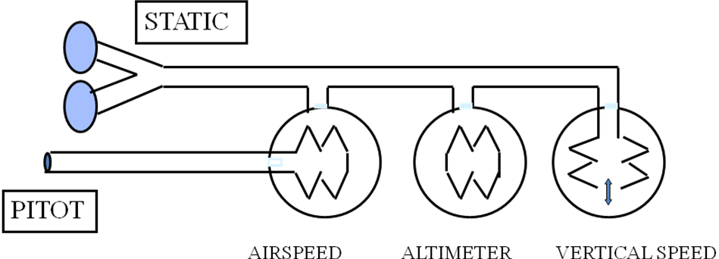

Airspeed Indicator
- Va is not shown on the Airspeed Indicator.
- Red Radial Line?
- Vne
- Vmc in Muli-Engine
- Blue Radial Line?
- Vyse in Multi-Engine

Airspeed Indicator
- Subject to errors at High Angle of Attack
- If Pitot Tube is sealed, ram air pressure remains constant.
- What happens in a climb with sealed Pitot?
- Airspeed increases due to reduced static pressure.

Altimeter
- What is standard Sea Level Pressure?
- How do 14.7 psi and 29.92 “ Hg relate?
- What about 1013.2?
- Why does it change?
- Where is 1/2 atmosphere?
- How do you explain Density Altitude?
- Why High to low and Hot to cold - - ?

Altimeter
- High to Low Lookout Below
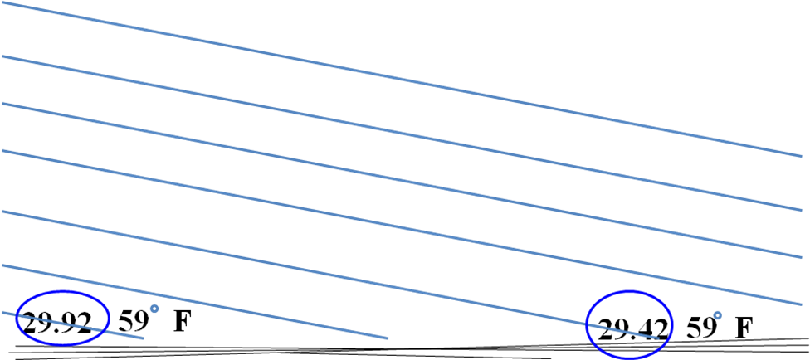

Altimeter
- Hot to Cold, Look Out Below
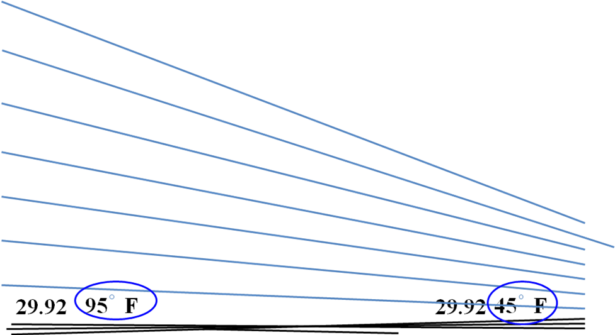

Gyroscopic Instruments
- Sources:
- Vacuum
- Electricity
- Speed of Rotation Increases Both
- Precession
- Rigidity in Space
- Only one instrument uses Precession as a tool

Electric Gyro
- Turn Needle/Turn Coordinator
- Operates on precession.
- Rotation rate is critical
- Spinning too fast, standard rate indication?
- = slower rate of turn.
- Spinning too slow, standard rate indication?
- = faster rate of turn.

Turn Needle vs. Turn Coordinator

Vacuum Gyros
- Attitude Indicator
- Heading Indicator
- Rely on rigidity in space
- We can Set the GHI
- How does the GAI know where level is?

Attitude Gyro
- Air is forced onto rotor then goes through center axis and out slits on four sides
- Pendulous Vanes
- If Axis Not Vertical
- 90° around rotation closes up, other side opens
- Precession

Draw the Vacuum System
- Should operate at 4.75 to 5.25 hg
- What happens if it is outside these limits?
- Low = more wobbling
- High = more wear.

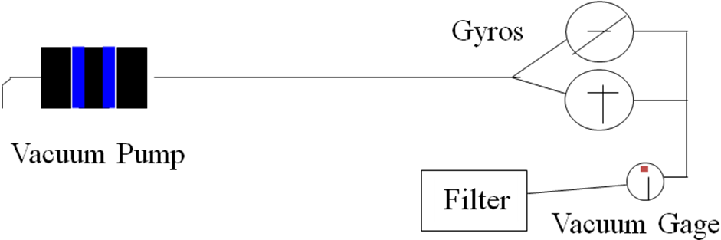

Electrical System
- Memorize these three facts
- A Generator doesn’t start to generate until reaching approximately 1100 rpm. An alternator produces electrical power at low rpm.
- The engine can run with the battery and alternator turned off.
- (Generators were replaced with alternators after 1964.) Watch out for old airplanes)

Oxygen Systems
- “Aviators Breathing Oxygen”
- Continuous Flow Below FL240
- Diluter systems are usually installed in jets
- Pressure Demand systems installed in jets which can operate above FL450

Oxygen Checklist
P Pressure
R Regulator
I Indicators
C Controls
E Emergency

Engine Systems
- Four Strokes
- Ignition
- Fuel System
- Fuel-Air Mixture Control
- Induction System
- Detonation
- Electrical System

Four Stroke Internal Combustion Engine
Intake Exhaust
- Intake OPEN CLOSED
- Compression CLOSED CLOSED
- Power CLOSED CLOSED
- Spark ignites fuel
- Exhaust CLOSED OPEN

Ignition System
- A proper mixture burns blue
- Excessively Rich Mixture Causes Plug Fouling
- Dual Ignition Provides Better Ignition
- Ground Wire Required to Shut Off Magneto

Mag Switch
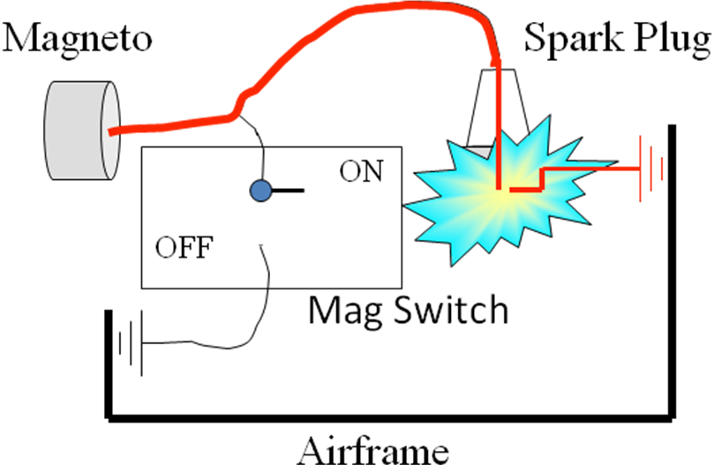

Fuel Induction System
- Fuel injection sprays fuel into cylinders Eliminates induction system icing
- Provides better distribution
- Carburetor - float or pressure type?
- Float, works just like the toilet bowl
- Pressure, works just like an institutional toilet

Mixture
- Ratio WEIGHT of fuel : WEIGHT of air
- A given volume of air has fewer molecules at altitude. (It weighs less per cubic inch)
- Lean to Peak EGT then enrich a specified number of degrees

Manifold Pressure
- What does it read when stopped
- Turbocharger driven by exhaust gasses
- Turbocharger will keep MP constant until waste gate is fully open (on some models)
- Turbocharger can exceed engine limits

Is Manifold Pressure Gage Required in the PA28RT201?

DETONATION
- Explosion of fuel rather than even burning
- Orange flame rather than blue
- Causes extreme pressures in cylinders
- Causes power reduction
- It “Pings.” You can hear it in your car, but not in an airplane.

Electricity
- What’s the difference between a Generator and an Alternator
- What’s the difference between a Starter and Alternator?
- What happens when you keep the starter engaged after the engine starts?

Excessive Engine Temperatures
- Caused by Mixture Too Lean
- Or by Too Much Power
- Or by Too Slow an Airspeed

Will Cause:
- Increased Fuel Consumption
- Increased Oil Consumption
- Possible Permanent Damage

Propellers
- Design
- Forces
- Constant Speed Propellers
- Critical Engine of Multi-Engine Airplane

Propeller Design Terms
- Efficiency = Thrust HP / Brake HP
- Blade angle = chord to plane of rotation
- Effective pitch = distance actually moved
- Propeller slip = geometric pitch - effective pitch
- Why is the propeller twisted?
- To provide near constant angle of attack at cruise

Left Turning Tendencies Associated with Power (LTTAP)
- Gyroscopic Precession - When is it a LTTAP?
- Spiral Slipstream
- “P” Factor
- Torque
How could we design out some of these?

Critical Engine
- See diagram on 3-26

Constant Speed Propellers
- Changes blade angle to maintain RPM with varying airspeed and MP
- How?

Max power is absorbed at small angle of attack, high RPM

Over Square
- Is a good rule of thumb for an airplane that doesn’t have a power chart.
- Good rule of thumb for A.R.S. pilots (Airplane Repossession Specialists).
- Over Square is more efficient if allowed by the manufacturer.
- 65% in the Arrow is ±26”mp and 2200 rpm

