**Name_________________________________**

**BI232 Action Potential Graphing Exercise**

Recall from BI231 that Na+ and K+ are critical for action potential formation in neurons. This is also true in the formation of action potentials in cardiac autorhythmic (pacemaker) and contractile cells. In addition, in cardiac autorhythmic and contractile cells Ca2+ is also required for the action potential.

1. The graph below illustrates an action potential produced in a ventricular cardiac contractile cell. Superimpose on this graph what the action potential would look like under each of the following conditions:

# a. In the presence of a K+ channel blocker such as Amiodarone used clinically to reduce K+ current.

# (Label this curve A)

b. In the presence of a Na+ channel blocker such as Lidocane used clinically to reduce Na+ current. (Label this curve B)

c. In the presence of a Ca2+ channel blocker such as Propafenone used clinically to reduce Ca2+ current. (Label this curve C)

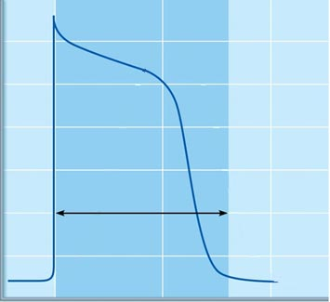

2. The graph below illustrates action potentials produced in autorhythmic cells. Consider the effect of the autonomic nervous system on this action potential wave form. Superimpose on the graph below what the action potential would look like under each of the following conditions:

a. The effect of stimulating the sympathetic nervous system (Label S). Also indicate what type of channel(s) (Na+, K+ and/or Ca2+) is affected and what type of receptor is activated.

b. The effect of stimulating the parasympathetic nervous systems (Label P). Also indicate what type of channel(s) (Na+, K+ and/or Ca2+) is affected and what type of receptor is activated.

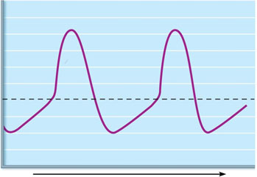

**Case Study**

74-year-old woman admitted to emergency department

**Chief Complaint:** Increasing shortness of breath and peripheral edema.

**History:** Martha Wilmington, a 74-year-old woman with a history of rheumatic fever while in her twenties, presented to her physician with complaints of increasing shortness of breath ("dyspnea") upon exertion. She also noted that the typical swelling she's had in her ankles for years has started to get worse over the past two months, making it especially difficult to get her shoes on toward the end of the day. In the past week, she's had a decreased appetite, some nausea and vomiting, and tenderness in the right upper quadrant of the abdomen.

Additional **history** includes: Diabetes Mellitus II (DMII); Hypertension (HTN) and Chronic Kidney Disease (CKD)

**Medications**: Metformin (an oral medication for DMII); Minipress (Prazosin) (an oral medication for high blood pressure); Spironolactone (a diuretic medication for fluid build-up related to heart failure): Lisinopril (look it up!)

**Physical examination:** Martha's jugular veins were noticeably distended (JVD). Auscultation of the heart reveals a low-pitched, rumbling systolic murmur, heard best over the left upper sternal border. In addition, she had an extra, "S3" heart sound.

Note: Rheumatic fever can produce scaring of the heart valves leading to regurgitation. A low-pitched, rumbling systolic murmur, S3 heart sound, peripheral edema (swelling of the ankles) and JVD indicates that the atrioventricular valve is regurgitating blood back into the right atrium during ventricular contraction.

**Labs:** K+ is 6.1 mEq/L (normal range is 3.5 – 5.0 mEq/L); BNP is 1120 (normal is < 100); Hct is 32% (Normal is 37% - 47%)

Note: (BNP = B-type natriuretic peptideis cardiac neurohormone secreted by ventricular myocytes in response increased wall stress that occurs when heart failure develops and worsens. The level of **BNP** in the blood increases when heart failure symptoms worsen, and decreases when the heart failure condition is stable.)

1. Suggest why Martha’s Hct is low. *Support your answer.*

2. Which term more accurately describes the stress placed upon Martha's heart -- increased pre-load or increased afterload?

3. What is the general term describing Martha's condition? How does the BNP lab result support this diagnosis?

4. How might Martha's heart compensate for the above condition?

**Martha was placed on telemetry which revealed cardiac arrhythmias**

5. Why might Martha’s condition result in cardiac arrhythmias?

6. Would the condition of hyperkalemia produce an increase or a decreased slope during the rising phase (phase 0) of the cardiac muscle depolarization?

7. Martha is started on a medication called digoxin (look it up!). Why was she given this medication, and how does it work? Draw a cardiac contractile cell action potential under the influence of digoxin.